**FULLSTACK PROJECT**

**(2021-2022)**

**SYNOPSIS**

**GLA UNIVERSITY, MATHURA**

**Department of Computer Engineering & Applications**

Institute of Engineering & Technology



**TOPIC: Mini Project Synopsis on E-Learning**

**Submitted By :**  **Submitted to:**

**Name** : Adarsh Verma **Faculty**: Mr. Akash kumar Choudhary

**Id** : adarsh.verma_cs19@gla.ac.in Technical Trainer

**Name**: Vaibhav Choudhary

**Id** : vaibhav.choudhary_cs19gla.ac.in

**DECLARATION**

|  |  |  |  |
| --- | --- | --- | --- |
| **Name** | **Section** | **Uni. Roll no.** | **Mail id** |
| Abhas Raghuvanshi | E | 191500008 | abhas.raghuvanshi_cs19@gla.ac.in |
| Adarsh Verma | E | 191500051 | adarsh.verma_cs19@gla.ac.in |
| Surabhi Sharma | D | 191500827 | surabhi.sharma_cs19@gla.ac.in |
| Vaibhav Choudhary | F | 191500885 | vaibhav.choudhary_cs19@gla.ac.in |
| Kunwar Nabeel Khan | O | 191500422 | nabeel.khan_cs19@gla.ac.in |

We hereby declare that I this project is done by us.

Thank you.

E-Learning Website

# Introduction

Overview

* + - All the functional/non-functional requirements, corresponding DFD’s, UML and Use Case Diagrams have been organized in this report. Along with these designs, this report also contain the essential data of this project.
    - The complete description of the application followed by the functionalities has been listed initially. Later on, the Webpage has been described diagrammatically with the help of different designing tools like Data Flow Diagram, Use Case Diagram, Interaction Diagram and E-R Diagram.

**About the Project:**

In today’s generation students are more depended on the internet to find the solutions and notes and they often waste their time in searching notes and solutions so they have to visit different websites for finding proper notes and solutions to accomplish their needs. And we often find that some websites have some issue of downloading the notes and solutions and it is difficult to download. Or maybe it’s difficult to get the sample papers with different sets and according to regions.

**Primary Reason to Choose This Project:**

E-Learning is changing the usual learning experience. It has become the new standard way of learning and is highly beneficial to students due to its flexibility, low cost, and user experience.

**The Main Objective of the Project**

* This website is mainly for school level and college students
* Providing notes , solutions , videos lecture and sample paper
* Easy to download notes , solutions and sample paper on one click
* Easily get all the content of learning in free of cost
* Enhance the learning of students
* Reliable and Efficient for users
* Our first approach for website is to analysis the problems that students is facing in their daily life in field of online study.
* As it is a E-Learning website , the most important is to download the proper notes , solutions and sample papers.
* We download the content or study material from various website ( websites are provides in references ).
* Next approach is to make our website attractive and easy to use .
* Here comes the stage of implementation where we have to code and developing the required web pages according to the requirements.
* After implementation, the most important is testing and to find the bugs in our website.

**Scope Of the Project**

E learning has rapidly evolved from a thing of the future to a practical approach towards education. It will continue to be an extremely useful classroom teaching tool as well as self-study platform. With the rise of virtual reality technology and augment reality solutions, experimental subjects, skill-based learning and military training will come to depend more heavily on e-learning solutions.

**Working Methodology Of the Project**

Our methodology is designed to help you take maximum advantage of the internet technologies. It incorporate all aspects related to our website and allows us to ensure that the final product is of the highest standards. We ensure that all your deliverables are completed in time, within budget also we will try to solve each and every problem efficiently.

**Details About the Hardware and the Software System Requirements:**

Supported Operating system: -

* Windows 7, 8, 10 or Linux

Web Browser :-

* Google Chrome , Firefox , Safari , Mozilla , Internet Explorer

Software Requirements :

* Visual Studio Code

Hardware Requirements (Minimun): -

* 20 GB OFHARDDISK
* Processor i3 (7th Gen)
* 1024 x 768Display
* Internet
* Minimum Marshmallow version 7.0 ( for android )
* Pentium IV or higher, (PIV-300GHz recommended)
* Hard-Disk 250GB or more
* RAM 4GB or more
* Processor i3 (7th Gen)

**Listing Out testing technology**

Frontend :

* + - HTML ( front-end )
    - CSS
    - Bootstrap

Backend :

* + - JavaScript (back-end )
    - MySQL (back-end )
    - php
    - Xampp server

**Data Flow Diagram:**

Level-0 DFD

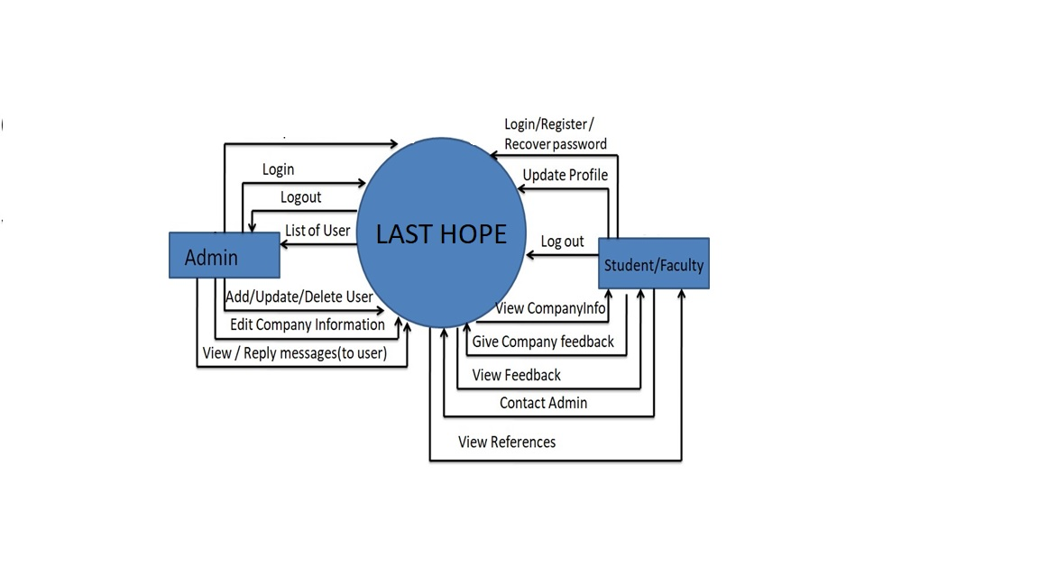

Level-1 DFD

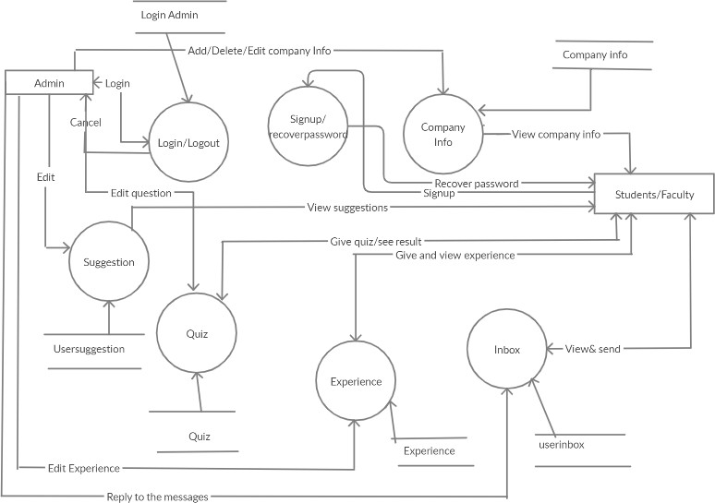

**References:**

* [**www.javatpoint.com**](http://www.javatpoint.com/)
* [**www.w3school.com**](http://www.w3school.com/)
* [**www.tutorialspoint.com**](http://www.tutorialspoint.com/)
* [**www.youtube.com**](http://www.youtube.com/)
* **www.google.com**